**Module 9**

**Assignment 1**

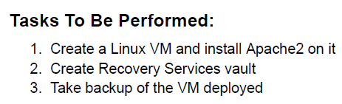

1. Create a VM and Install Apache 2 : sudo apt install apache2 -y

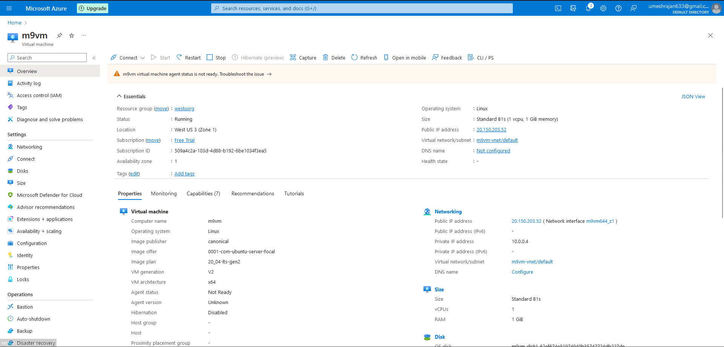

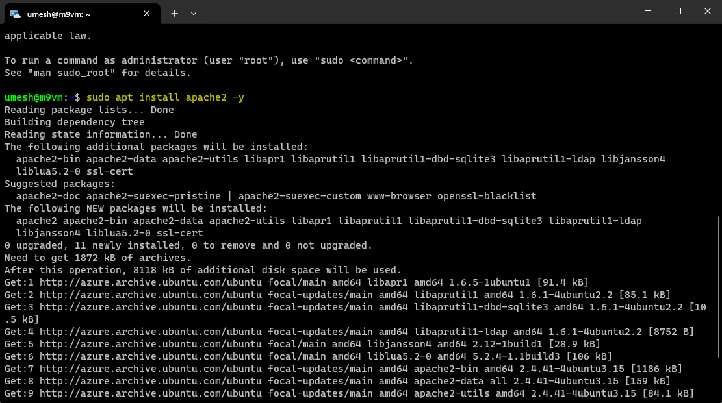

1. The apache2 package is installed.
2. Go to Backup and Site Recovery > Create Recovery Services Vault.

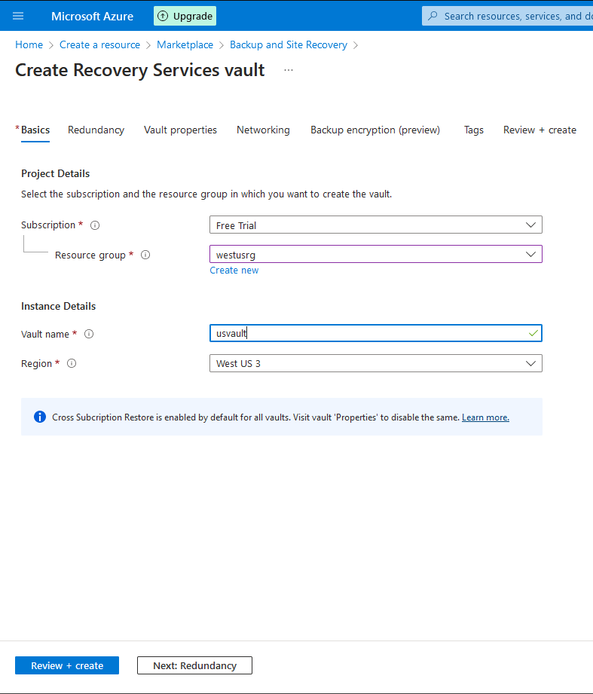

1. Proceed to Backup by going inside the VM > Backup. Choose the created Recovery Services Vault.

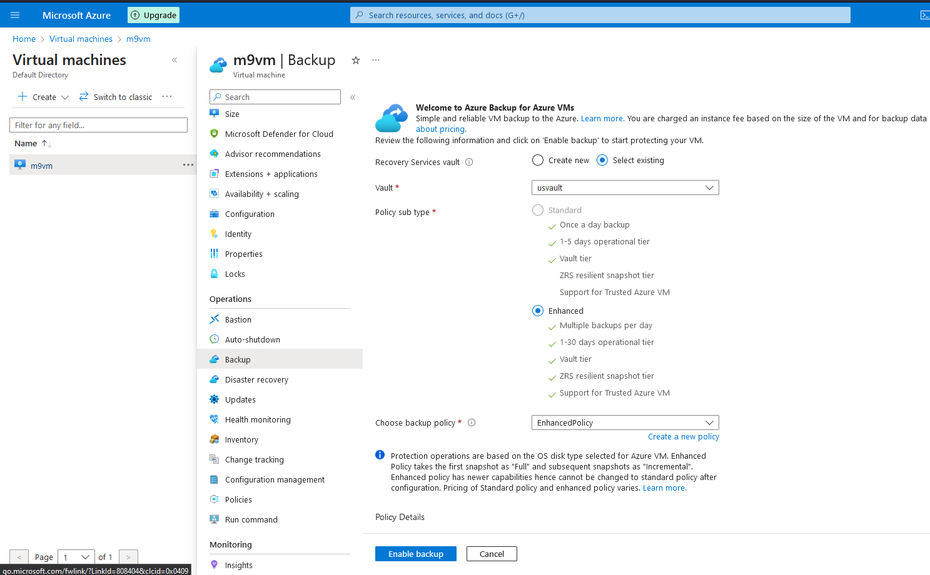

1. The backup has been set.

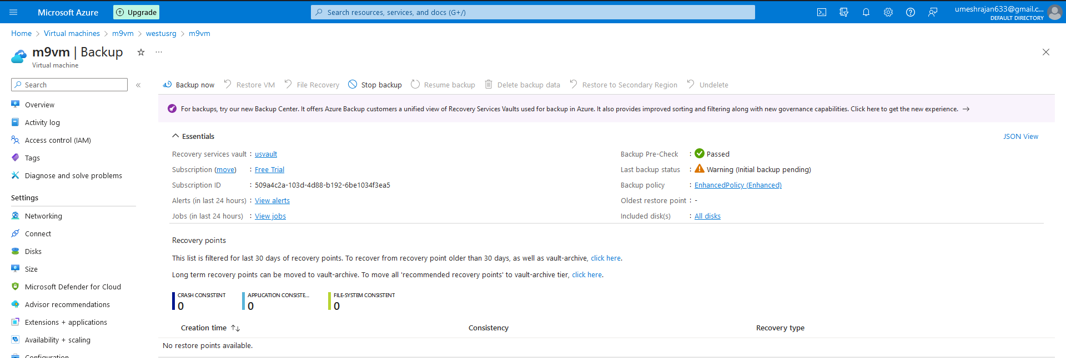

**Assignment 2**

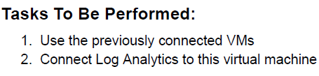

1. Go to VM deployed earlier and select Logs and Enable.

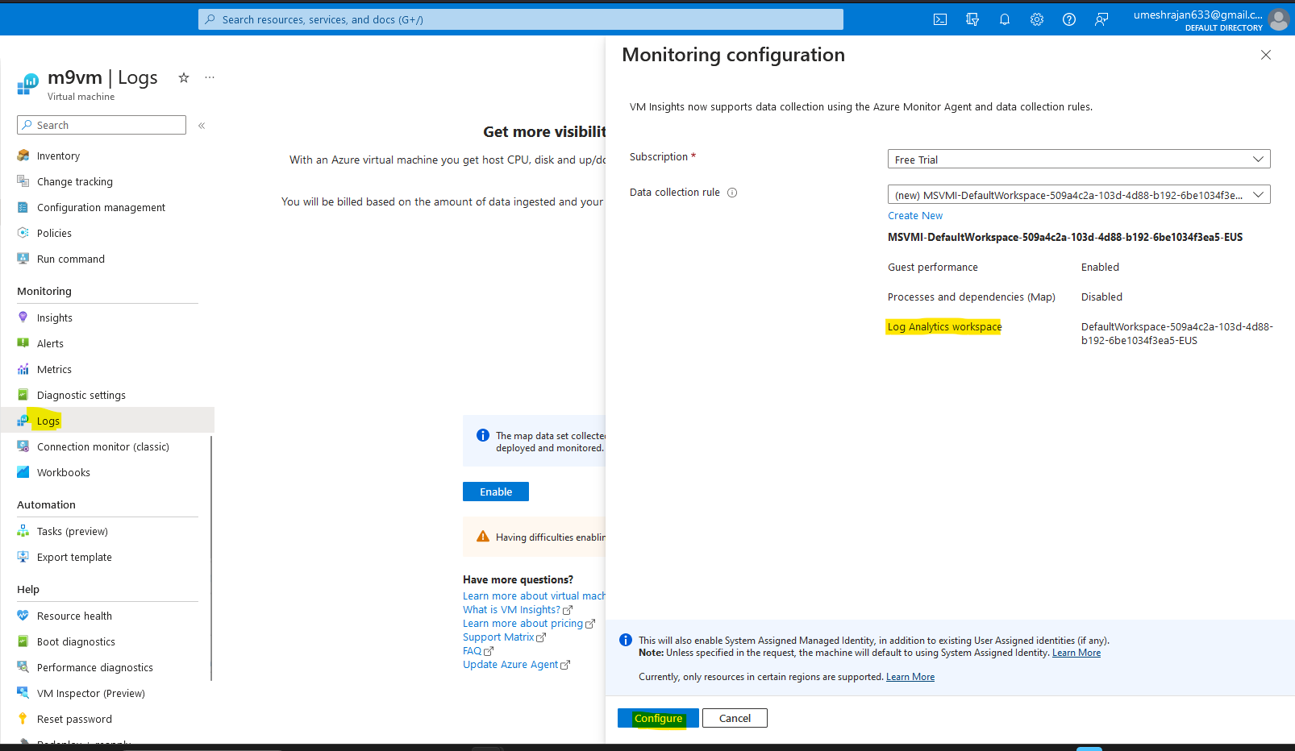

1. The VM is Connected to the Log Analytics Workspace.

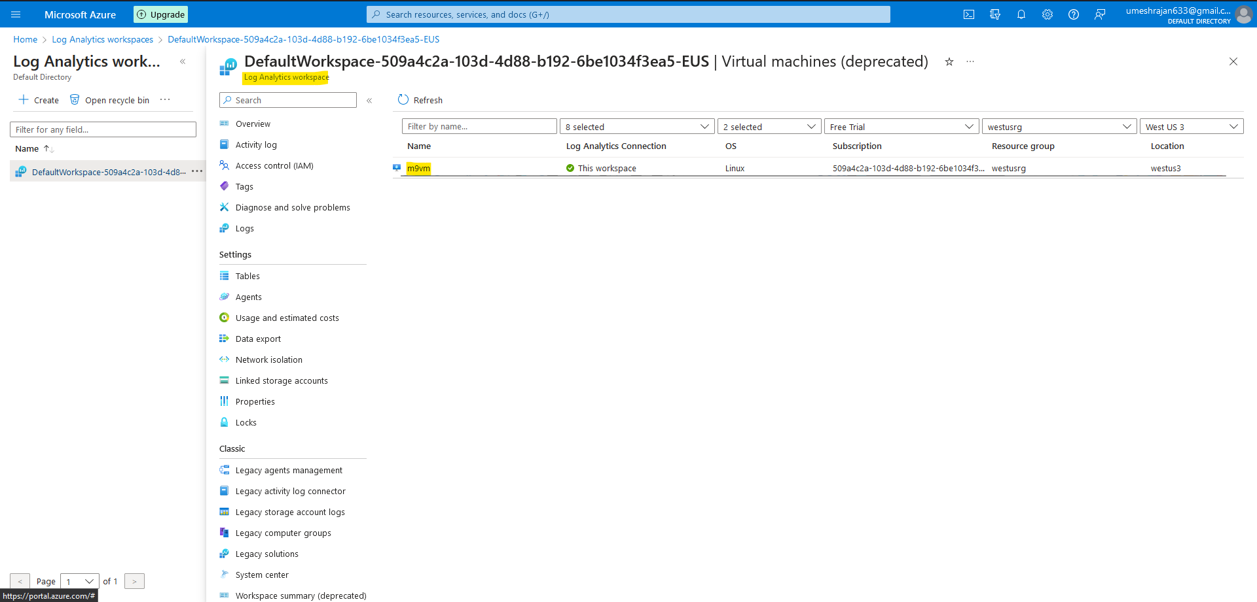

**Assignment 3**

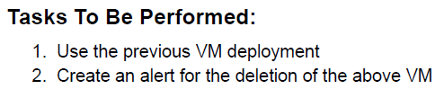

1. Create a Custom Rule to receive alert for Deletion of VM.

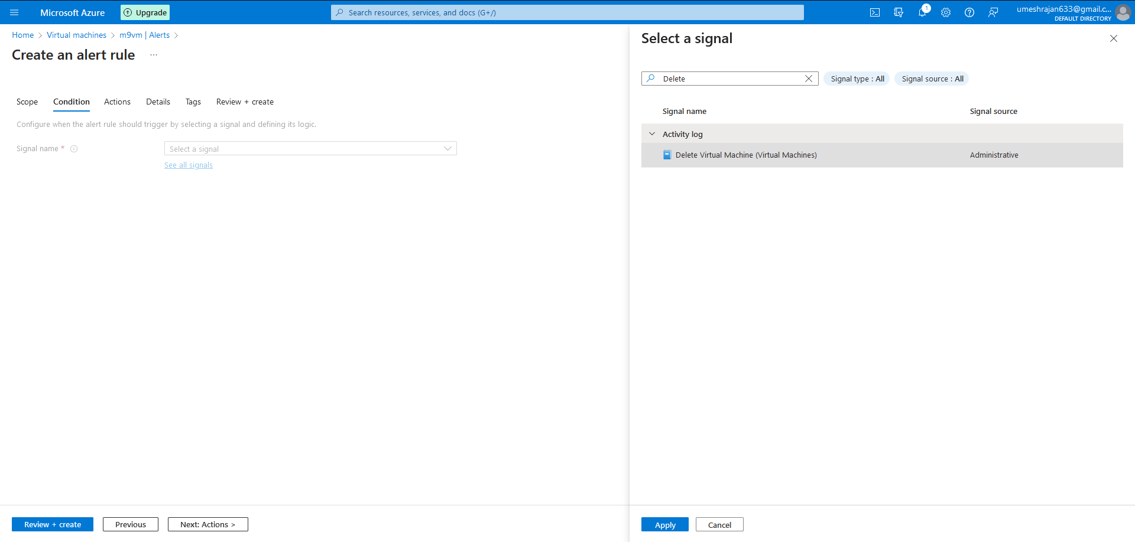

1. Create a Action so that we receive an Email when a delete action on the VM is performed.

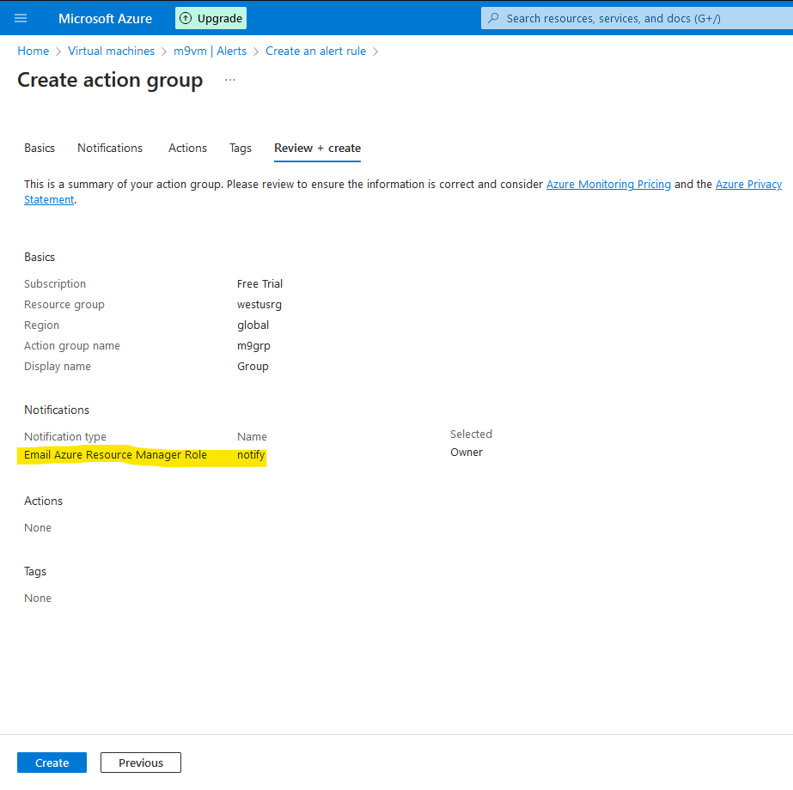

1. The alert is configured.

